**Instagram User Analytics**

**Project - 2**

**TITLE- Instagram User Analytics**

**Project Overview:**

The purpose of this project is to hold SQL skills to analyze user interactions and engagement with the Instagram application. As a data analyst working with the product team, the goal is to provide valuable insights to support decision-making within the business. The project involves answering specific questions posed by the management team related to marketing analysis and investor metrics.

**SQL Tasks :**

1. **Marketing Analysis:**
2. **Loyal User Reward:** The marketing team wants to reward the most loyal users, i.e., those who have been using the platform for the longest time.  
   Your Task: Identify the five oldest users on Instagram from the provided database.

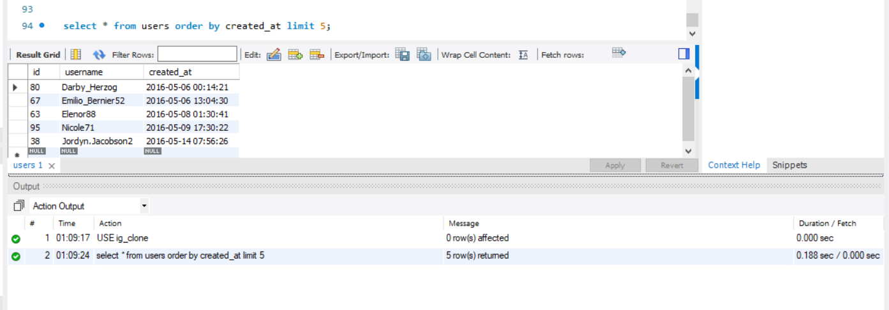

1. **Inactive User Engagement:** The team wants to encourage inactive users to start posting by sending them promotional emails.  
   Your Task: Identify users who have never posted a single photo on Instagram.

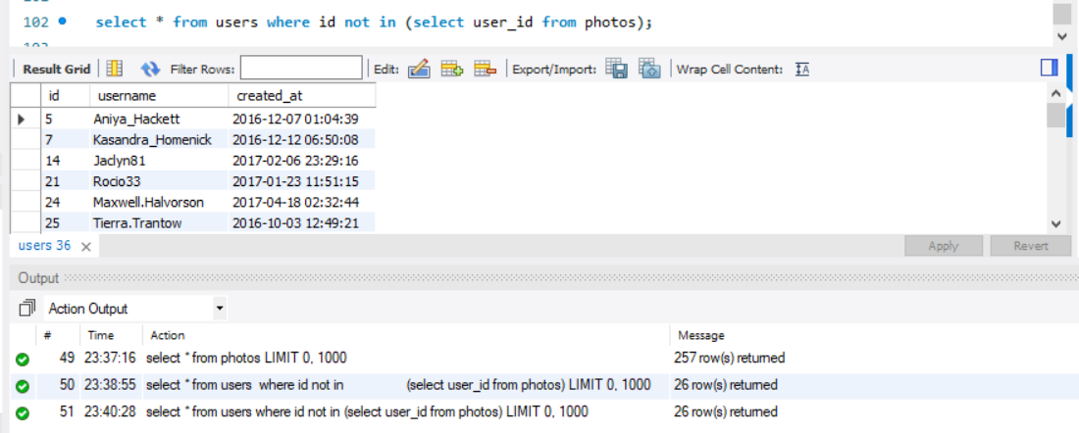

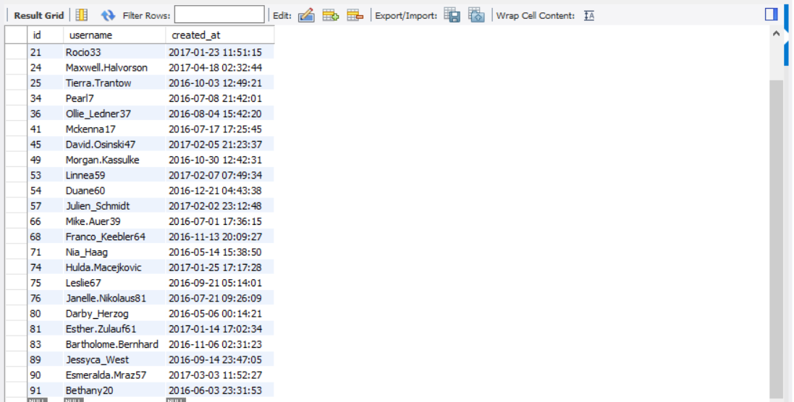

1. **Contest Winner Declaration:** The team has organized a contest where the user with the most likes on a single photo wins.  
   Your Task: Determine the winner of the contest and provide their details to the team.

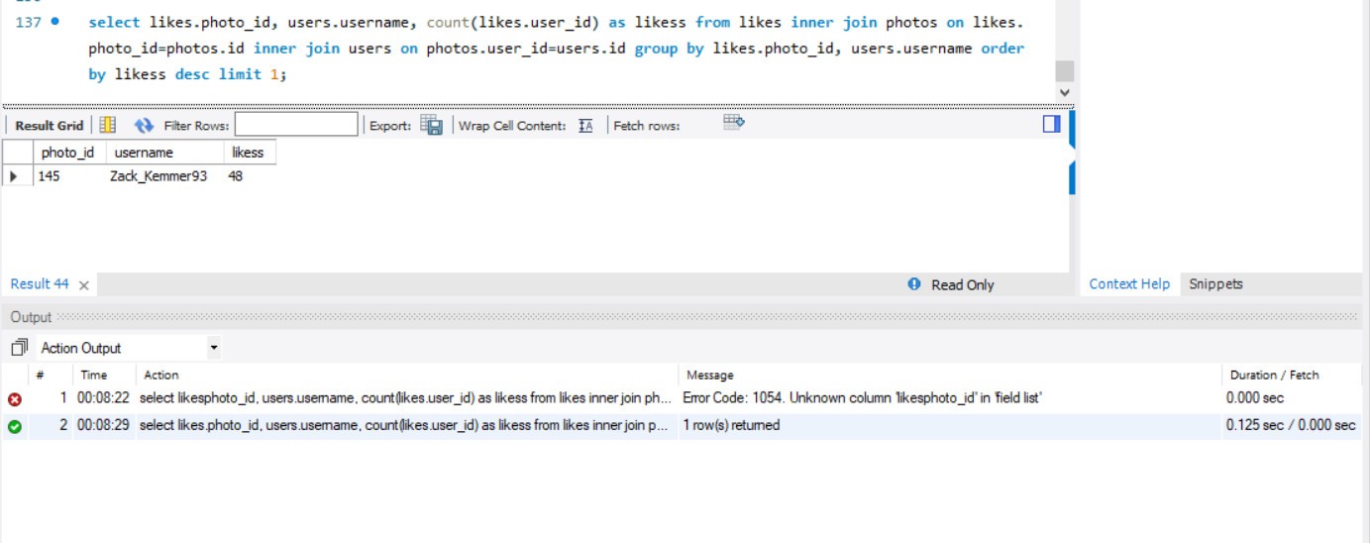

1. **Hashtag Research:** A partner brand wants to know the most popular hashtags to use in their posts to reach the most people.  
   Your Task: Identify and suggest the top five most commonly used hashtags on the platform.

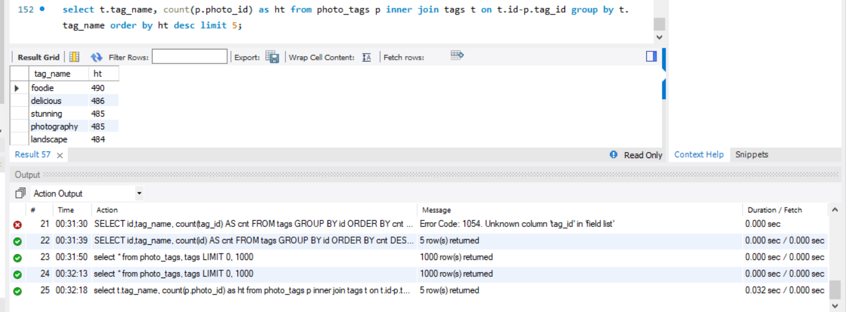

1. **Ad Campaign Launch:** The team wants to know the best day of the week to launch ads.  
   Your Task: Determine the day of the week when most users register on Instagram. Provide insights on when to schedule an ad campaign.

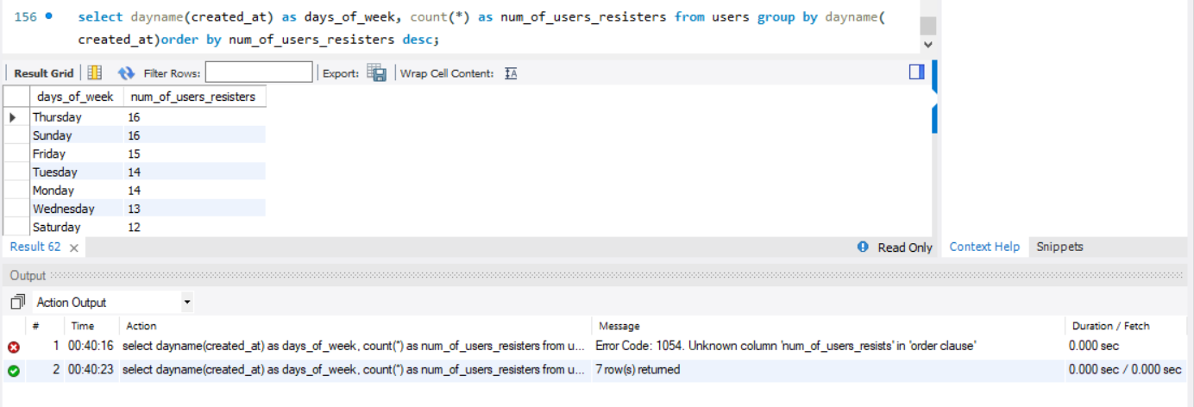

**B) Investor Metrics:**

1. **User Engagement:** Investors want to know if users are still active and posting on Instagram or if they are making fewer posts.  
   Your Task: Calculate the average number of posts per user on Instagram. Also, provide the total number of photos on Instagram divided by the total number of users.

Calculate the average number of posts per user on Instagram

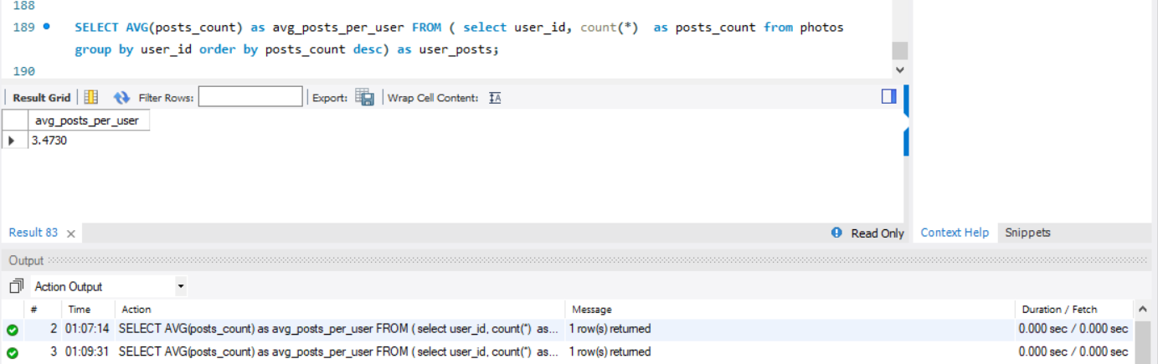

the total number of photos on Instagram divided by the total number of users.

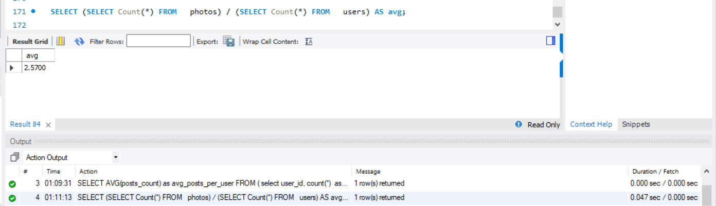

1. **Bots & Fake Accounts:** Investors want to know if the platform is crowded with fake and dummy accounts.  
   Your Task: Identify users (potential bots) who have liked every single photo on the site, as this is not typically possible for a normal user.

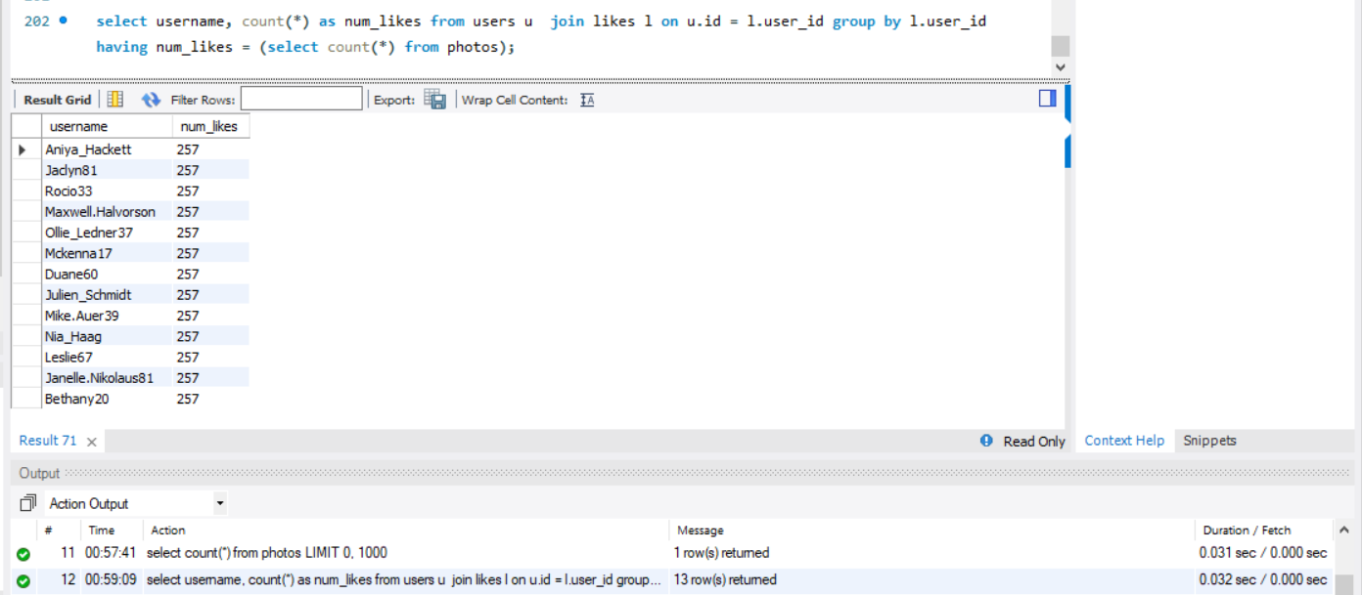

* + **Project Description:-**

project description outlines a scenario where you, as a data analyst working with the product team at Instagram, are tasked with analyzing user interactions and engagement using SQL and MySQL Workbench. The goal is to provide valuable insights to assist the product team in making informed decisions about the future direction of the Instagram app.

* + **Approach:-**

**Database Creation:**

The Executed provided commands to create the necessary database.

Therefore, Ensured proper structure and data representation.

**Marketing Analysis:**

* Identified the five oldest users using registration dates.
* Identified inactive users by checking post counts.
* Determined contest winners based on likes.
* Analyzed post hashtags to suggest top five.
* Determined the best day for ad campaign launches based on user registration.

**Investor Metrics:**

by Calculated average posts per user and total photos divided by total users.

Identified potential bots by finding users liking every photo.

**Report Preparation:**

Documented SQL queries along with outputs.

Created a report in PDF format.

* + **Tech-Stack Used:- Tech-Stack Used:**

MySQL Workbench (Version 8.0 CE):

Chosen for its user-friendly interface and powerful SQL query capabilities.

Provides a seamless environment for database creation, management, and analysis.

* + **Insights:**

**User Engagement:**

* + Average posts per user indicated healthy user activity.
  + Understanding user engagement is crucial for decision-making in feature development and marketing strategies.
  + **Bots & Fake Accounts:**
  + Identified potential bots to maintain a genuine user base.
  + Addressing fake accounts contributes to a more reliable platform.
  + **Marketing Insights:**
  + Recognized the loyalty of the oldest users for possible loyalty programs.
  + Identified inactive users for targeted re-engagement strategies.
  + Declared contest winners and suggested popular hashtags for marketing campaigns.
  + **Ad Campaign Optimization:**
  + Determined the best day for ad campaign launches based on user registration patterns.
* **Result:-**

**Achievements:**

* + Successfully completed all tasks, providing valuable insights for decision-making.
  + how as a business or data analyst we work on real-time data to take any data-driven decision.
  + Achieved a comprehensive understanding of user behavior.

**Impact:**

* + The analysis contributes to informed decision-making for product development, marketing, and user engagement.
  + Insights derived from the project can potentially influence the future development of Instagram.

**Drive Link**

By following this approach, the project showcases the application of SQL skills to extract meaningful insights from Instagram user data, contributing to the strategic direction of one of the world's most popular social media platforms.

**Top of Form**